“”

Rev. Debra McGuire
Bethany Presbyterian Church
Mark 4:35-41
June 23, 2024

Mark 4:35-41

³⁵On that day, when evening had come, he said to them, “Let us go across to the other side.” ³⁶And leaving the crowd behind, they took him with them in the boat, just as he was. Other boats were with him. ³⁷A great windstorm arose, and the waves beat into the boat, so that the boat was already being swamped. ³⁸But he was in the stern, asleep on the cushion; and they woke him up and said to him, “Teacher, do you not care that we are perishing?” ³⁹He woke up and rebuked the wind, and said to the sea, “Peace! Be still!” Then the wind ceased, and there was a dead calm. ⁴⁰He said to them, “Why are you afraid? Have you still no faith?” ⁴¹And they were filled with great awe and said to one another, “Who then is this, that even the wind and the sea obey him?”

The portions of the Gospel of Mark that we are reading this month are filled with stories of Jesus trying to offer examples and explanations of who Jesus is and what the kingdom of God might look like. Last week we read Mark’s version of the mustard seed story, and discovered that the kingdom of God is like mustard seeds scattered and planted, that grow even when the one doing the planting does not know. The kingdom of God is like a world where transitions happen by the grace and power of God.

This week, we are not reading a parable spoken by Jesus, but we are witnesses to an experience the disciples had with Jesus. The disciples aren’t imagining something from a parable. They are experiencing something in real life.

The disciples took Jesus with them in the boat, just as he was. Just as he was. No pretense, no special clothing, no special sepulcher and servants. Part of Jesus’ mystique was that he did these incredible things, but looked like a regular guy. The disciples had seen Jesus heal, had heard his parables and wanted to follow him. But it was kind of confusing to try to figure out how Jesus did his healings, where he got the gall to break temple and sabbath rules, and what he was talking about when he told his parables. Confusing maybe, but still compelling enough that Jesus was the one the disciples went to when they feared for their lives in the storm.

They were afraid in the storm. The destructive and unpredictable nature of the sea and the wind must have been even more than these life-long fishermen could manage. The gospel of Mark sets this scene at night, which would have been even more dangerous for them. The fear we have when we see the reality of danger is a very real bodily fear.

But the fear they felt after Jesus calmed the wind and the sea, was a whole different level. “Who then is this?” To know something in your head, is one thing. But to experience something live, is another. They had seen Jesus’ miracles, and they had heard his parables. But there on the boat, in a real life moment by moment experience of the drama and fear of their situation, and the experience of witnessing Jesus act and the sea and wind become calm must have been something. There is a deeper impact when we experience an event than there is if we just hear about or think about an event. We know differently, when we feel.
The disciples would have been familiar with the songs and Psalms from their culture and any time in the temple. Imagine if one psalm in particular, psalm 107, came to mind when you were in the boat and had just seen Jesus, just as he was, a regular guy, able to command the wind and rain. Hear these words from Psalm 107:

“Some went down to the sea in ships, doing business on the mighty waters;
²⁴ they saw the deeds of the Lord, his wondrous works in the deep.
²⁵ For he commanded and raised the stormy wind, which lifted up the waves of the sea.
²⁶ They mounted up to heaven; they went down to the depths; their courage melted away in their calamity;
²⁷ they reeled and staggered like drunkards and were at their wits’ end.
²⁸ Then they cried to the Lord in their trouble, and he brought them out from their distress;
²⁹ he made the storm be still, and the waves of the sea were hushed.
³⁰ Then they were glad….

The disciples had heard of God’s power before, specifically with regard to nature, and all of creation for that matter. In the boat, they witnessed Jesus, this regular guy, doing what only God could do. “Who then is this?” The disciples were not glad – not yet anyway. I’m sure they were happy to be safe, but the new kind of fear and awe they felt would take some time to make any sense.

Discovering that Jesus is God brings a new kind of fear and awe that is still taking some time to make any sense. Humans have run the spectrum over time, of full believers, skeptics, or deniers of Biblical stories. But humans have been reflecting on God with all of their senses, and with all of the tools at their disposal throughout history. Jesus calming the sea is a particular story among many that has been depicted in art, poetry, story, and allegory throughout history.

In your bulletins you have a picture of a painting by Rembrandt, his only known seascape, from 1633, called The Storm on the Sea of Galilee. I thought it would be interesting to have a look at what other minds from history were in the world at the same time, to kind of get an overview of what society at large was like. Here are some famous people from the 1600’s.

Shakespeare
Galileo
Newton
Rembrandt
DeCarte
Vermeer
John Milton
Pascal
John Locke
Oliver Cromwell
Henry Purcell

These were artists, musicians, philosophers, physicians, scientists. During the period of the Renaissance, new worlds were discovered and new ways of seeing and thinking developed. For an artist like Rembrandt to paint this picture of an event taken from the Bible, during a time when huge strides were coming to be in scientific and philosophical ways of thinking, strikes me as speaking to the power of the story itself. Even in the 1600’s Rembrandt’s painting is still asking, “Who then is this?” I don’t know how religious Rembrandt was, but one doesn’t spend all that time on a painting of an idea if it isn’t compelling. Perhaps believing, perhaps still questioning, his painting speaks to the power of the human capacity for hope.

Here is a more recent take on this scene from the gospel of Mark. This poet speaks to the awe that the disciples must have felt, but wonders how long it lasted, and if there was any change. After all, it would be pretty frightening on a deeper level to change ones whole self after an experience like that. Here is “Maybe” by Mary Oliver.

“Maybe” by Mary Oliver

Sweet Jesus, talking
his melancholy madness,
stood up in the boat
and the sea lay down,
silky and sorry.
So everybody was saved
that night.
But you know how it is
when something
different crosses
the threshold — the uncles
mutter together,
the women walk away,
the young brother begins
to sharpen his knife.
Nobody knows what the soul is.
It comes and goes
like the wind over the water —
sometimes, for days,
you don’t think of it.
Maybe, after the sermon,
after the multitude was fed,
one or two of them felt
the soul slip forth
like a tremor of pure sunlight
before exhaustion,
that wants to swallow everything,
gripped their bones and left them
miserable and sleepy,
as they are now, forgetting
how the wind tore at the sails
before he rose and talked to it —
tender and luminous and demanding
as he always was —
a thousand times more frightening
than the killer sea.
If we try to imagine what it must have been like to be one of the disciples we have to first try to imagine ourselves in the picture somehow. If you look at the Rembrandt for a moment, can you picture yourself in that scene? Maybe you can picture yourself in a different kind of boat? During daylight? Maybe you’re taking the ferry across the bay.
Maybe you can’t picture yourself in that picture, but imagine how deeply frightening it might be to be out on the water in the dark when the wind and waves begin to toss the boat to and fro. Even though the disciples were all people who could take care of themselves on the water, the storm must have been pretty bad to make them afraid. Can you imagine yourselves in a different picture maybe but just as afraid?
Who would you hope for in that moment? A person of faith might have been taught and experienced enough of the Christian story to call out or pray to God. A person who isn’t so sure, might have other resources at their disposal that are more grounded, based in humanity. Both would be fine.
So far these are just cognitive exercises. Read the biblical text. See the painting. Consider the poem. Imagine yourself. What if we took it out of the realm of imagination and the realm of our brains, and brought our next look into the realm of our hearts, our felt experiences?
The part where I see myself in the biblical text for today is at that moment of astonishment when the wind and sea go calm, at Jesus’ bidding. That recognition of the work of God, right in the moment in front of our eyes, would be like a bolt of lightning – powerful, instant, and might jolt us into a whole new world. A world that looks just like the one we’re in now, but with a masterful pilot at the helm. A world that looks just like the one we’re in now, but we can lose that fictional belief that we have to go it alone, never ask for help, keep a stiff upper lip, never let our imperfections be visible; the fictional belief that perfection is the ultimate goal; the fictional belief that we are not loveable unless someone else says so; we can lose that belief someone handed to us once upon a time, that says God loves some people more than others, that God rejects some.
The God of this text today is the God who loves everyone equally, has the power to quell our fears, and is the foundation of all that is good. Amen.

https://cepreaching.org/commentary/2024-06-17/mark-435-41-4/
https://www.discoverwalks.com/blog/world/top-10-famous-people-from-the-1600s/

https://www.saltproject.org/progressive-christian-blog/2021/6/13/be-still-salts-lectionary-commentary-for-fourth-week-after-pentecost

https://www.saltproject.org/progressive-christian-blog/2021/6/13/maybe-by-mary-oliver

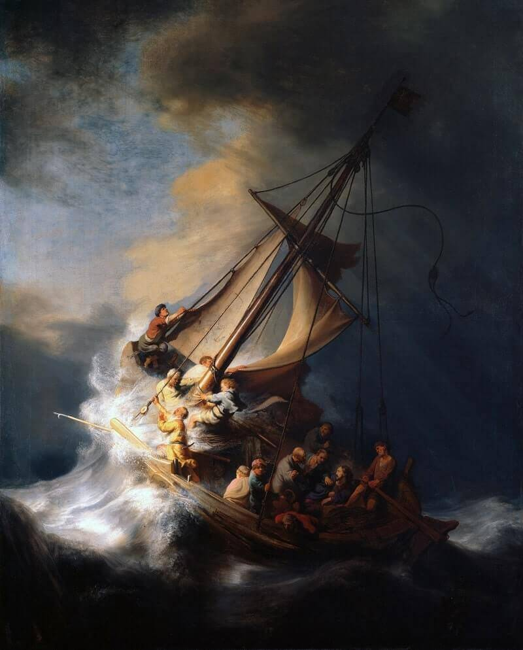
Storm on the Sea of Galilee, 1633 (Rembrandt)

