“”

Rev. Debra McGuire

Bethany Presbyterian Church

James 2:1-17

September 8, 2024

***James 2:1-17***

***My brothers and sisters, do not claim the faith of our Lord Jesus Christ of glory while showing partiality. 2For if a person with gold rings and in fine clothes comes into your assembly, and if a poor person in dirty clothes also comes in, 3and if you take notice of the one wearing the fine clothes and say, “Have a seat here in a good place, please,” while to the one who is poor you say, “Stand there,” or, “Sit by my footstool,” 4have you not made distinctions among yourselves and become judges with evil thoughts? 5Listen, my beloved brothers and sisters. Has not God chosen the poor in the world to be rich in faith and to be heirs of the kingdom that he has promised to those who love him? 6But you have dishonored the poor person. Is it not the rich who oppress you? Is it not they who drag you into the courts? 7Is it not they who blaspheme the excellent name that was invoked over you?***

***8If you really fulfill the royal law according to the scripture, “You shall love your neighbor as yourself,” you do well. 9But if you show partiality, you commit sin and are convicted by the law as transgressors. 10For whoever keeps the whole law but fails in one point has become accountable for all of it.***

***11For the one who said, “You shall not commit adultery,” also said, “You shall not murder.” Now if you do not commit adultery but you murder, you have become a transgressor of the law. 12So speak and so act as those who are to be judged by the law of liberty. 13For judgment will be without mercy to anyone who has shown no mercy; mercy triumphs over judgment.***

***14What good is it, my brothers and sisters, if someone claims to have faith but does not have works? Surely that faith cannot save, can it?******15If a brother or sister is naked and lacks daily food 16and one of you says to them, “Go in peace; keep warm and eat your fill,” and yet you do not supply their bodily needs, what is the good of that? 17So faith by itself, if it has no works, is dead.***

***“15If a brother or sister is naked and lacks daily food 16and one of you says to them, “Go in peace; keep warm and eat your fill,” and yet you do not supply their bodily needs, what is the good of that?”***

Yesterday I saw a video on Instagram of a ceramic artist named Stanley Tong.1 He sculpted 15 vases and while the clay was still wet, he fired real bullets from a variety of firearms at the clay. The resulting vases were pit fired with these “wounds” still in place. These pieces were part of a show called “Thoughts and Prayers” and were part of an auction he put together to fund the Sandy Hook Promise organization funding gun violence prevention programs.

These words of James’ could be heard today maybe saying this version:

*If a child is frightened or a parent is grieving the loss of a child to gun violence and one of us says to them “Our thoughts and prayers are with you,” and yet we do not do something about the gun violence, what is the good of that?* (my version)

In 1999, Frank DeAngelis was principal at Columbine High School, when two students opened fire and killed more than a dozen people. He received a call a couple of days later from Bill Bond, the principal at Heath High School in Paducah, Ky., where there had been a shooting in 1997. Mr. Bond said to him, “You don’t even know what you need, but here’s my number.” By 2019 there had been so many other school shootings that Frank DeAngelis and others formed The Principal Recovery Network and put together a guide to help principals of what to do next.2 I wonder if the principal of Apalachee High School in Georgia received a call from them this week?

The letter of James is all about action. Faith without works is dead. Our task according to last week’s reading from James is to care for orphans and widows and remain unstained by the world. Oh, how I wish I was unstained by the world! I wish I was unstained by the human caused tragedies that leave me feeling helpless and lost, and ashamed that I am part of a society that cannot seem to keep our children safe in schools. What works might my faith lead me to do? Surely despair is not the end of the conversation! Surely paranoia is not the end of the conversation!

Christian scripture from the Old and New testaments, Jewish writings, Mother Theresa, anthropologists and even an 18th century politician all have wise words for us about never thinking we are too small or insignificant to have an impact on big things.3

This letter of James is no exception. Always calling us to action, bluntly telling us that “faith without actions that evidence that faith, is not actually faith at all.”4 Not doing, is not an option. In the first scenario from the text today, James points out that when we show favoritism between a rich person who we treat well and a poor person who is only allowed to sit at our feet, we have made distinctions amongst ourselves and have become judges of others. “Judges with evil thoughts” adds James, which is not how to love our neighbor as ourself – the “royal law” which James refers to. A commentator I read says this about today’s text: “For the author of James, to show preference to the wealthy, especially those who performatively demonstrate their riches, while overlooking or even actively oppressing the lowly and poor is not only dishonorable but starkly revealing of a person’s rotten inner being.”4

For James, faithful living includes what we do and what we leave undone. Our commentator writes, “Faith without works is not faith; conviction without action is emptiness.” Maybe my shame about living in a society that cannot seem to keep our children safe is schools, is my reaction to that emptiness. We often have strong convictions and feel anxiety and emptiness when we don’t know how to do something impactful. We don’t know where to start, we don’t know what we are capable of, we feel particularly anxious if we don’t feel capable of much at all.

Despair and paranoia are never the end of the conversation. There is always hope. Hope is something that is best practiced, and it must be practiced, in community. Hope must be practiced because we have lost our ability to recognize it. The volume of the noise of the world is as high as it has been in many years – but the sound of hope is louder. We need to practice hope by hearing it from the mouths of others, from seeing actions of others, from experiencing resilience of our own or others. God is calling us to joy! That is so hard to hear when we feel shaky, or we’re struggling, or going through our own tragedies. We never want to minimize that. God will provide the hope we need for healing, for bringing peace. It’s a promise from God.

May God bless this world with a hope worth working for.

Amen.

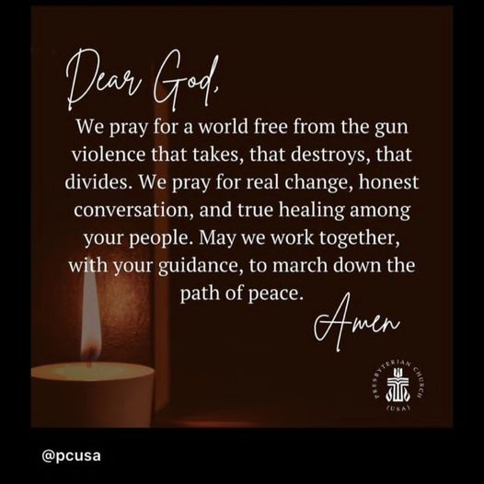

1<https://www.instagram.com/reel/C9sgBFgvLN3/?igsh=MzRlODBiNWFlZA==>

2https://www.npr.org/2024/09/07/nx-s1-5103875/how-a-network-of-principals-provides-support-for-school-shooting-survivors

3Zechariah, Galatians, Ethics of the Fathers, chapter 2 (Talmud), Margaret Mead, William Wilburforce, (18th c. politician working to end slavery)

4<https://www.workingpreacher.org/commentaries/revised-common-lectionary/ordinary-23-2/commentary-on-james-21-10-11-13-14-17-6>