“Jesus calls your name”
Rev. Debra McGuire
Bethany Presbyterian Church, San Bruno, CA
John 20:1-18
April 9, 2023 Easter Sunday 10am

John 20:1-18

¹Early on the first day of the week, while it was still dark, Mary Magdalene came to the tomb and saw that the stone had been removed from the tomb. ²So she ran and went to Simon Peter and the other disciple, the one whom Jesus loved, and said to them, “They have taken the Lord out of the tomb, and we do not know where they have laid him.” ³Then Peter and the other disciple set out and went toward the tomb. ⁴The two were running together, but the other disciple outran Peter and reached the tomb first. ⁵He bent down to look in and saw the linen wrappings lying there, but he did not go in. ⁶Then Simon Peter came, following him, and went into the tomb. He saw the linen wrappings lying there, ⁷and the cloth that had been on Jesus’ head, not lying with the linen wrappings but rolled up in a place by itself. ⁸Then the other disciple, who reached the tomb first, also went in, and he saw and believed; ⁹for as yet they did not understand the scripture, that he must rise from the dead. ¹⁰Then the disciples returned to their homes.

¹¹But Mary stood weeping outside the tomb. As she wept, she bent over to look into the tomb; ¹²and she saw two angels in white, sitting where the body of Jesus had been lying, one at the head and the other at the feet. ¹³They said to her, “Woman, why are you weeping?” She said to them, “They have taken away my Lord, and I do not know where they have laid him.” ¹⁴When she had said this, she turned round and saw Jesus standing there, but she did not know that it was Jesus. ¹⁵Jesus said to her, “Woman, why are you weeping? For whom are you looking?” Supposing him to be the gardener, she said to him, “Sir, if you have carried him away, tell me where you have laid him, and I will take him away.” ¹⁶Jesus said to her, “Mary!” She turned and said to him in Hebrew, “Rabbouni!” (which means Teacher). ¹⁷Jesus said to her, “Do not hold on to me, because I have not yet ascended to the Father. But go to my brothers and say to them, ‘I am ascending to my Father and your Father, to my God and your God.’” ¹⁸Mary Magdalene went and announced to the disciples, “I have seen the Lord”; and she told them that he had said these things to her.

It has been kind of cool, experiencing the reading of scripture as theater these last few weeks. There’s something about feeling as though the scene is filled with real people saying real things and doing real things. As an audience, I suspect it was a little hard to know who to look at while we were up here reading. That too brings some authenticity to the scripture because that’s what you do when you’re watching a group do anything. You shift a little bit each time a different person speaks and move your attention there. Even with scripture that might be familiar, it’s not always the same experience when many voices are heard.

Today’s scripture lesson is two acts. Act I begins dramatically, in the early morning darkness, Mary alone discovers a missing body. Sounds exactly like the first scene in any of my mystery shows. She runs to tell two of the disciples that a grave robber has taken the body, which would have been an appropriate assumption. All of them then run back to the tomb. Next is this strange explanation about who ran fastest and got there first. It reminds me of my brother and I when we were kids, walking home from somewhere. We’d approach our house and one of us would yell, “First one to the door wins!” And we’d take off, and there would be a winner. One of us might feel a little bad about losing. I don’t know about you, but when you were a kid, did you have this thing where you could yell out “I call!” it meant that you got what you wanted? For example, “I get the front seat, I call!” Or, “I get to sit next to mom, I call!” The perfect antidote to that feeling of losing was to yell “I call!” before you got to the front door. We’d approach the house, one of us would yell, “First one to the door wins!" and we'd take off running. But it didn’t matter who actually got there first because the one lagging behind would yell, “I get there first, I call!” Why the other one would begrudgingly accept that is still something I don’t understand. So Peter and the beloved disciple run, the beloved disciple gets there first, looks in and sees the linens, but doesn’t go in. Peter gets there then and goes in and sees the linen wrappings.

There’s a lot of speculation about this scene. Why didn’t the one who got there first actually enter the tomb right away? What did Peter think when he saw the linens but not Jesus’ body? Did the beloved disciple believe without entering the tomb? Just the stone rolled away was enough for him to remember Jesus’ words about rising after the third day?

I wonder what went through their heads? They must have remembered Jesus’ words about being killed and rising on the third day. If they remembered the events when Lazarus rose from the dead they would remember that Lazarus still needed to be unbound. But here, there was not a body, but only the remnants of having been unbound. Would grave robbers take the cloth off of the body in the grave they robbed? The two disciples returned to their homes, maybe to think about all of this. Maybe to talk over some of their questions – if Jesus did rise from the dead, where did he go? Maybe rising from the dead was kind of like evaporating and going somewhere called heaven? Maybe they were at the wrong tomb. They believed, but they did not yet understand.

Act II of the scripture begins in that same garden, near the same tomb, and Mary has stayed behind. She stands outside the tomb weeping. At one point she goes to the entrance and looks into the tomb and sees two angels sitting inside where Jesus body had been. They speak to her and wonder why she is crying. As she begins to ask them where the body of her Lord has been taken she turns and sees Jesus standing there. Maybe he looked familiar, but out of context perhaps, she assumed he was the gardener, a mere servant. The gardener asks her the same question that the angels asked her, “Woman, why are you weeping?” “For whom are you looking?” This is the same question Jesus asked those who were following him, after John the Baptist pointed out Jesus and said, there, that’s the guy I’m talking about. They guy for whom I am not even qualified to tie his sandals. Still speaking to the gardener, Mary explains again, if you know where he is tell me and I will take him away.

But when he calls her by name, maybe she wonders why the gardener would know her name, and she takes a longer focused look. How do you spell that sharp intake of breath that happens, a gasp, the opposite of a sigh – huh!!! When Jesus then tells her not to take hold of him, I imagine that she has exclaimed, “Teacher!” and then ran to hug him! “Do not hold on to me, because I have not yet ascended to the Father. But go to my brothers and say to them, ‘I am ascending to my Father and your Father, to my God and your God.’” So Mary, the first witness to the resurrected Christ, receives his command, and goes to the others and preaches the first sermon. “I have seen the Lord.”

Mary is the first example of living a life just as Mary Oliver has suggested – Mary was paying attention, she was astounded and she told about it!¹ Jesus called her by name, she recognized him, he gave her a command, and she answered that call.

All three of our characters have seen some hint of Jesus’ words coming true. Yes, he had been telling them these things, but it might have been hard to picture. Having just watched his horrible tragic death, they must have been stunned. In that state of mind, it’s often hard to find hope again, to find the focus to look again at this mere servant the gardener and realize that it is Jesus, the ultimate Servant Christ, standing calling our name.

This Easter I remind us that we all have been called. Not just once but many times. Every time we are sure of God’s presence and hear God calling our name, we feel secure in the knowledge that Christ is risen! It’s human and natural as we make our way through this world weighed down by natural forces like gravity, time, the weather, nature, not to mention our social circumstances, to feel or actually be forgotten, unloved, or even hated and persecuted.

The poor, the imprisoned, the hungry, the terrified school children, the Tennessee citizens who are without representation, the kids who came to the capital to protest and instead heard the voices of those voting to unseat those who would speak up for them; the trans kids who have had their choices and very futures stolen from them, the parents and children who’s safety is at the mercy of the gun lobby and their elected officials. Jesus calls their names. Those who suffer illnesses, live lives with trauma or memory of trauma, those who have no trust or hope. Jesus calls our names.

As a way to offer you something like the experience of being called as Mary was, I want to invite you to put yourself into this story beginning with Act II. You have stayed behind after others have returned home, weeping outside of the tomb. I’m going to read the second half of scripture changing Mary to you. When I get to the part where Mary speaks to the gardener and then Jesus says her name, I want you to say your own name out loud instead of Mary. The words Jesus said to her happens many times. So let’s practice. “Sir, if you have carried him away, tell me where you have laid him, and I will take him away.” “Jesus said to you, -name-“ Very good! Ok. Close your eyes if you’d like and enter the scene.

You are in the garden. You have been to the tomb in the early morning. It’s still dark so maybe you are seeing things, but the stone is not in front of the tomb! You assume there have been grave robbers so you run back to get help to find Jesus. Your friends come, they go inside the tomb, and are confused by what they see. They return to their homes.

¹¹But you stood weeping outside the tomb. As you wept, you bent over to look into the tomb; ¹²and you saw two angels in white, sitting where the body of Jesus had been lying, one at the head and the other at the feet. ¹³They said to you, “Why are you weeping?” You said to them, “They have taken away my Lord, and I do not know where they have laid him.” ¹⁴When you had said this, you turned round and saw Jesus standing there, but you did not know that it was Jesus. ¹⁵Jesus said to you, “Woman, why are you weeping? For whom are you looking?” Supposing him to be the gardener, you said to him, “Sir, if you have carried him away, tell me where you have laid him, and I will take him away.” ¹⁶Jesus said to you, “[name!’” You turned and said to him in Hebrew, “Rabbouni!” (which means Teacher). ¹⁷Jesus said to you, “Do not hold on to me, because I have not yet ascended to the Father. But go to my brothers and say to them, ‘I am ascending to my Father and your Father, to my God and your God.’” ¹⁸You went and announced to the disciples, “I have seen the Lord”; and you told them that Jesus had said these things to you.”

Today, Easter Sunday, even in these dark days of division, growing distrust, separation and hostility, there is still hope. There is always hope. Christ is risen! For all.
Alleluia!

Let us pray,

Living Christ, you are risen from the dead!
Love reigns!
You are life stronger than death;
raise our eyes to see you
as the new day dawns.
— A New Zealand Prayer Book

¹“Instructions on Living a Life” by Mary Oliver

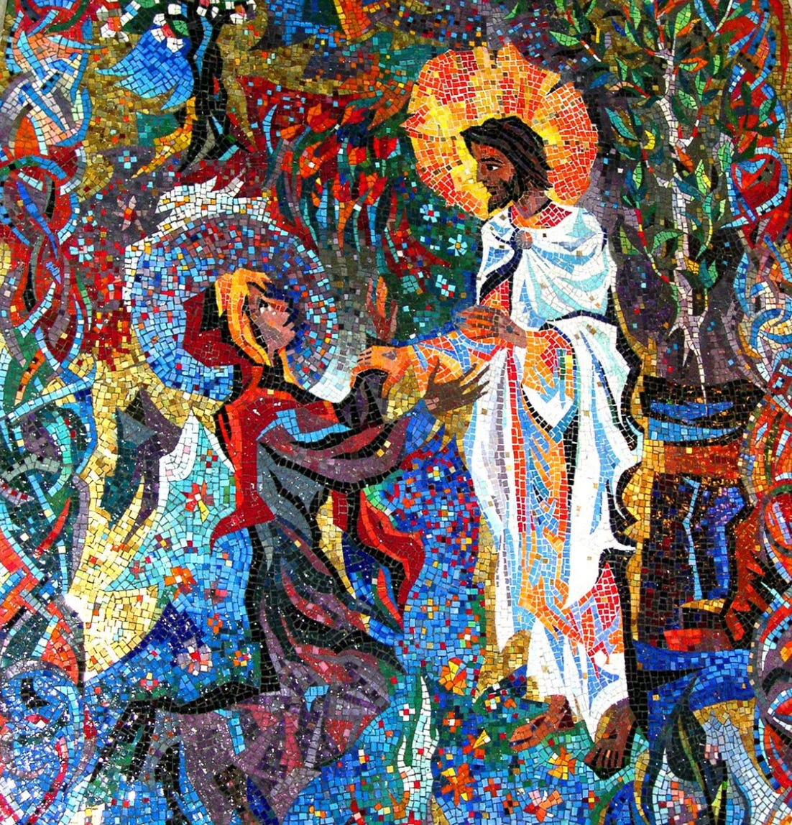

Detail from a mosaic at the Washington National Cathedral, Washington DC.

